MC RUGGED BISHOP

**WITH**

MATTERS

**RELATIONSHIP**

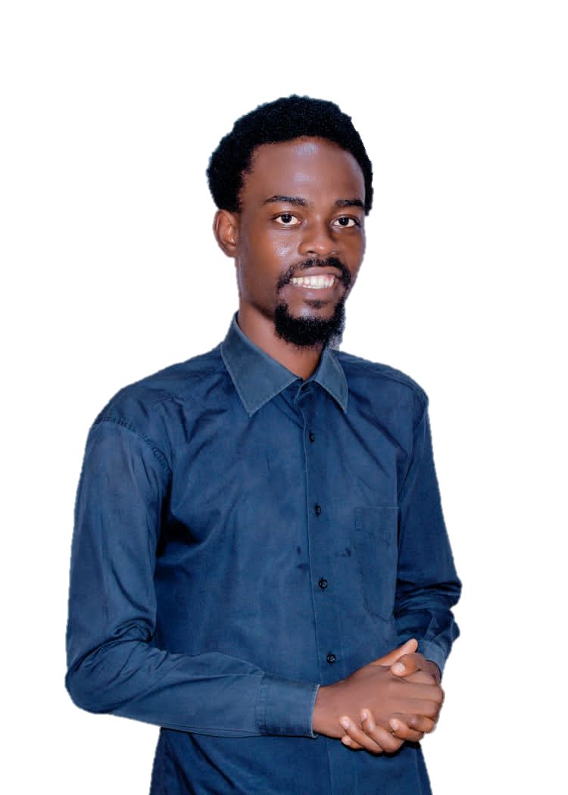

**PACESETTERS IN CHRST**

**YOUTH FELLOWSHIP**